**MENAMPILKAN NILAI MAKSIMAL DAN MINIMAL MENGGUNAKAN ARRAY**

#include <iostream>

#include <conio.h>

using namespace std;

int main()

{

cout<<"-- Menampilkan Nilai Maksimal Dan Minimal Menggunakan Array --"<<endl<<endl;

int i, min, max;

int B[7]= {7,4,8,5,7,8,9};

min=B[0], max=B[0];

for (i=0; i<7 ; i++)

{

cout<<B[i]<<" ";

}

for (i=0; i<7 ; i++)

{

if (B[i]>max)

{

max=B[i];

}

if (B[i]<min)

{

min=B[i];

}

}

cout<<endl<<endl;

cout<<"Nilai Maksimum : "<<max<<endl;

cout<<"Nilai Minimal : "<<min<<endl;

getch();

}

***Output Program***

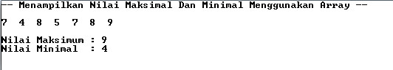

**PROGRAM PENJUALAN MENGGUNAKAN STRUCTURE**

#include <iostream>

#include <iomanip>

#include <stdio.h>

#include <conio.h>

using namespace std;

struct dt_penjualan{

char barang[50];

int harga;

int jumlah;

int g_total;

int t_pembelian;

int bayar;

}transaksi[5];

int main()

{

cout<<"================================"<<endl;

cout<<"| DATA PENJUALAN BARANG |"<<endl;

cout<<"| PT. SURYA KENCANA NO 1 |"<<endl;

cout<<"================================="<<endl<<endl;

int i, t_pembelian=0, looping;

cout<<" --TRANSAKSI PENJUALAN BARANG--"<<endl<<endl;

for(i=1; i<6; i++){

cout<<" Masukkan Data Transaksi Barang "<<endl;

cout<<"+--------------------------------+"<<endl;

cout<<"|Nama Barang :"; cin>> transaksi[i].barang;cout<<endl;

cout<<"|Harga Barang :"; cin>>transaksi[i].harga;cout<<endl;

cout<<"|Jumlah Barang :"; cin>>transaksi[i].jumlah;cout<<endl;

transaksi[i].g_total=transaksi[i].harga*transaksi[i].jumlah;

cout<<"|Grand Total :"<<transaksi[i].g_total<<endl;

if (transaksi[i].g_total>=50000){ transaksi[i].t_pembelian=transaksi[i].g_total*0.2;

transaksi[i].bayar=transaksi[i].g_total-transaksi[i].t_pembelian;

cout<<"|Diskon :"<<transaksi[i].t_pembelian<<endl;

cout<<"|Bayar :"<<transaksi[i].g_total-transaksi[i].t_pembelian<<endl;

}

else

if(transaksi[i].g_total>=25000){ transaksi[i].t_pembelian=transaksi[i].g_total*0.1;

transaksi[i].bayar=transaksi[i].g_total-transaksi[i].t_pembelian;

cout<<"|Diskon :"<<transaksi[i].t_pembelian<<endl;

cout<<"|Bayar :"<<transaksi[i].g_total-transaksi[i].t_pembelian<<endl;

}

else

{

cout<<"|Diskon : 0"<<endl;

cout<<"|Bayar :"<<transaksi[i].g_total-transaksi[i].t_pembelian<<endl;

}

cout<<"+--------------------------------+"<<endl<<endl; }

system("cls");

cout<<”====================================================="<<endl;

cout<<"| DATA PENJUALAN BARANG |"<<endl;

cout<<"| PT. SURYA KENCANA NO 1 |"<<endl; cout<<"================================================"<<endl<<endl;

cout.flags(ios::left);

cout<<setw(15)<<"NO NAMA BARANG HARGA JUMLAH SUBTOTAL DISKON TOTAL BAYAR"<<endl;

cout<<" -----------------------------------------------------------------------"<<endl;

for(looping=1; looping<6; looping++){

cout<<setiosflags(ios::left)<<setw(7)<<looping; cout<<setiosflags(ios::left)<<setw(15)<<transaksi[looping].barang;

cout<<setiosflags(ios::left)<<setw(10)<<transaksi[looping].harga;

cout<<setiosflags(ios::left)<<setw(7)<<transaksi[looping].jumlah;

cout<<setiosflags(ios::left)<<setw(10)<<transaksi[looping].g_total;

cout<<setiosflags(ios::left)<<setw(10)<<transaksi[looping].t_pembelian;

cout<<setiosflags(ios::left)<<setw(10)<<transaksi[looping].bayar;

cout<<endl;

}

cout<<endl;

cout<<" \n*** T E R I M A K A S I H ***";

getch();

return 0;

}

Contoh Inputan Program

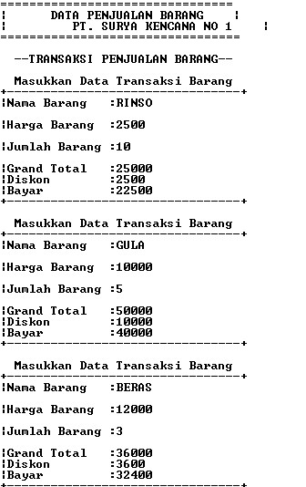

Output Hasil Akhir Dari Program

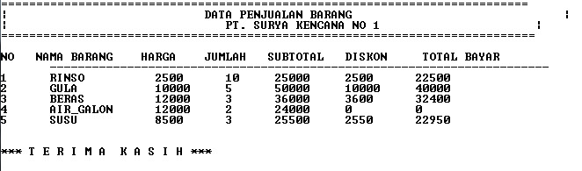

**PROGRAM HITUNG NILAI MAHASISWA MENGGUNAKAN STRUCTURE**

#include <iostream>

#include <conio.h>

using namespace std;

struct mhs{

char nim[5];

char nama[20];

int mt1;

int mt2;

int mt3;

int ipk;

}mahasiswa[6];

int main(){

//int mt1,mt2,mt3,ipk,ket;

int i,l;

cout<<"Masukkan Jumlah Mahasiswa : ";cin>>l;cout<<endl;

for(i=1;i<=l;i++){

cout<<"-------------------------------"<<endl;

cout<<"Masukkan Data Mahasiswa ke :";cout<<i<<endl;

cout<<"NIM :";cin>>mahasiswa[i].nim;

cout<<"Nama Mahasiswa :";cin>>mahasiswa[i].nama;

cout<<"Mata Kuliah 1 :";cin>>mahasiswa[i].mt1;

cout<<"Mata Kuliah 2 :";cin>>mahasiswa[i].mt2;

cout<<"Mata kuliah 3 :";cin>>mahasiswa[i].mt3;

mahasiswa[i].ipk=(mahasiswa[i].mt1+mahasiswa[i].mt2+mahasiswa[i].mt3)/3;

cout<<"IPK :";cout<<mahasiswa[i].ipk<<endl;

getch();

}

system("cls");

cout<<"+++++++++++++++++++++++++++++++++++++++++++++++++++++++++++++++++++++++++++++++++"<<endl;

cout<<" PROGRAM HITUNG NILAI MAHASISWA "<<endl<<endl;

cout<<" UNIVERSITAS PAMULANG "<<endl;

cout<<"+++++++++++++++++++++++++++++++++++++++++++++++++++++++++++++++++++++++++++++++++"<<endl<<endl<<endl;

cout<<"---------------------------------------------------------------------------------"<<endl;

cout<<"|| NO NIM NAMA || NILA || IPK KETERANGAN ||"<<endl;

cout<<"|| MAHASISWA || MATKUL 1 MATKUL 2 MATKUL 3 || ||"<<endl;

cout<<"---------------------------------------------------------------------------------"<<endl<<endl;

for(i=1;i<=l;i++){

cout<<i;cout<<".";

cout<<"\t";cout<<mahasiswa[i].nim;

cout<<"\t";cout<<mahasiswa[i].nama;

cout<<"\t\t";cout<<mahasiswa[i].mt1;

cout<<"\t";cout<<mahasiswa[i].mt2;

cout<<"\t";cout<<mahasiswa[i].mt3;

cout<<"\t";cout<<mahasiswa[i].ipk;

if(mahasiswa[i].ipk>=70 && mahasiswa[i].ipk <=100){

cout<<"\tLULUS"<<endl;

}

else if(mahasiswa[i].ipk<70){

cout<<"\tTIDAK LULUS"<<endl;

}

}

}

**Contoh Inputan Data**

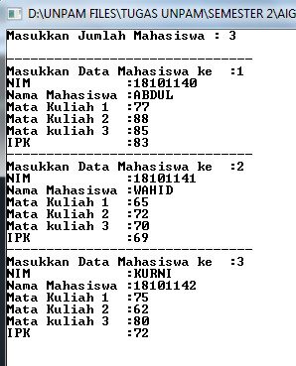

**Output Terahkir Dari Program**

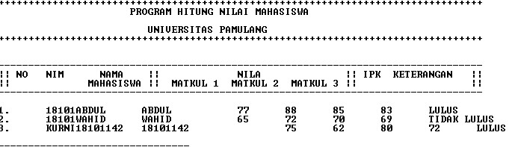

**PROGRAM MENGHITUNG GAJI KARYAWAN**

#include <iostream>

using namespace std;

int main(){

int jamkerja, honorharian, honor, lembur, gaji, jamlembur;

cout<<"Masukkan Jumlah Jam Kerja :";

cin>>jamkerja;

cout<<"Masukkan Honor Harian :";cin>>honorharian;

// lembur=(jamkerja-40)+5000;

if(jamkerja < 40){

honor=jamkerja*honorharian;

}

else {

honor=jamkerja*honorharian+100000;

jamlembur=jamkerja-40;

lembur=(jamkerja-40)*5000;

}

gaji=honor+lembur;

cout<<"\njumlah jam kerja :";cout<<jamkerja;cout<<"\tHonor Harian Rp.";cout<<honorharian<<endl;

cout<<"\njumlah jam lembur :";cout<<jamlembur<<endl;

cout<<"Uang Lembur Rp.";cout<<lembur<<endl;

cout<<"Honor Anda Rp.";cout<<honor<<endl;

cout<<"-------------------------------+"<<endl;

cout<<"Gaji yang diterima Rp.";cout<<gaji<<endl;

}

**Output Program**

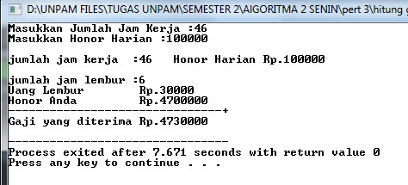

**Program Cari Nilai Minimum Dan Maksimum Dg Pointer**

#include <iostream>

using namespace std;

main(){

int *ptr;

int data[7]={70, 80, 100, 45, 75, 40, 90};

int elemen, max, min;

ptr=&data[0];

max=*ptr;

min=*ptr;

for (elemen=0; elemen<7; elemen++){

cout<<"isi indek ke ["<<elemen<<"]="<<data[elemen]<<""<<endl;

}

for (elemen=0; elemen<7; elemen++)

{

if (*(ptr+elemen)>max) max=*(ptr+elemen);

else if (*(ptr+elemen)<min) min=*(ptr+elemen);

}

cout<<"---------------------"<<endl;

cout<<"Nilai Maksimum :"<<max<<endl;

cout<<"Nilai Minimum :"<<min;

}

**Output Program**

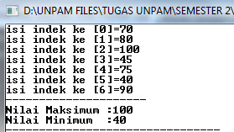

**Menghitung Luas Persegi Panjang Dengan Pointer**

#include <iostream>

using namespace std;

int main()

{

int panjang, lebar,luas;

int *ptr,*p,*l;

p=&panjang;

l = &lebar;

ptr = &luas;

cout<<"Masukkan Panjang :";

cin >>panjang;cout<<endl;

cout<<"Masukkan Lebar :";cin>>lebar;cout<<endl;

luas=(*p)*(*l);

cout<<"Luas Persegi Panjang :"<<*ptr;

}

**Output Program**

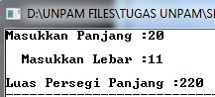

**Tugas Fungsi By Value**

#include <iostream>

using namespace std;

void fungsi (int &b){

//b=10;

cout << "addres b "<< &b <<endl;

cout << " nilai b "<< b <<endl<<endl;

}

int main()

**Output Program**

{

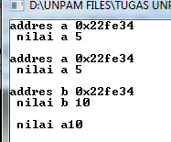 int a=5;

cout << "addres a "<< &a <<endl;

cout << " nilai a "<< a <<endl<<endl;

int &b =a;

cout << "addres a "<< &b <<endl;

cout << " nilai a "<< b <<endl<<endl;

fungsi(a);

cout << " nilai a"<< a <<endl;

int a=sizeof;

return 0;

}

**Function By Refrence**

#include <iostream>

using namespace std;

int main(){

int a=5;

cout<< " addres dari a :"<<&a<<endl;

cout<< " Nilad dari a :"<<a<<endl<<endl;

//reference

int &b=a;

**Output Program**

cout<<" Niladi dari b :"<<b<<endl;

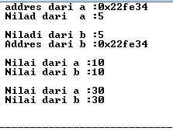 cout<<" Addres dari b :"<<&b<<endl<<endl;

b=10;

cout<< " Nilai dari a :"<<a<<endl;

cout<< " Nilai dari b :"<<b<<endl<<endl;

b=30;

cout<< " Nilai dari a :"<<a<<endl;

cout<< " Nilai dari b :"<<b<<endl<<endl;

}

**Program Quick Short Tugas Elearning Pert 9**

#include <iostream>

#include <conio.h>

using namespace std;

void quick_sort(int arr[], int left, int right)

{

int i = left, j = right;int tmp;

int pivot = arr[(left+right)/2];/* partition */

while (i<j){

while (arr[i] < pivot)

i++;

while (arr[j] > pivot)

j--;

if (i<=j){

tmp = arr[i];

arr[i] = arr[j];

arr[j] = tmp;

i++;j--;

};

}; /* recursion */

if (left < j)

quick_sort(arr, left, j);

if (i < right)

quick_sort(arr, i, right);

}

int main()

{

int i,n,data[50];

cout<<"Masukan banyak data: ";cin>>n;

for(i=0;i<n;i++)

{cout<<"Masukan data ["<<i<<"] : ";cin>>data[i];}

cout<<"\nData sebelum diurutkan: "<<endl;

for(i=0;i<n;i++)

{

cout<<data[i]<<" ";

}cout<<"\n";

quick_sort(data,0,n-1);//hasil pengurutan

cout<<"\nHasil pengurutan:\n";

{

int i;

for (i=0;i<n;i++)

cout<<data[i]<<" ";

cout<<"\n";

}getch();

}

**Output Program**

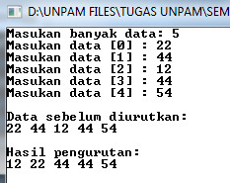

**Program Bubble Sort Elearning Pert 10**

#include <iostream>

using namespace std;

int data[5], data2[5];

int jdata;

void value(int a, int b)

{

int x;

x = data[b];

data[b] = data[a];

data[a] = x;

}

void bubble_sort()

{

for(int i=1; i<=jdata; i++)

{

for(int k=jdata; k>=i; k--)

{

if(data[k] < data[k-1])

{

value(k, k-1);

}

}

}

}

main()

{

cout << "Masukkan jumlah data: ";

cin >> jdata;

cout << endl;

for(int i=1; i<=jdata; i++)

{

cout << "Masukkan data ke-" << i << ": ";

cin >> data[i];

data2[i] = data[i];

}

cout<<"Data Sebelum Diurutkan "<<endl;

for (int i=1; i<=jdata; i++)

{

cout<<data[i]<<" ";

}

bubble_sort();

cout << "\nData Setelah diurutkan" << endl;

for(int i=1; i<=jdata; i++)

{

cout << data[i] << " ";

}

cout << endl;

system("pause");

}

**Output Program**

